The individual student work 2
- Build the following topology
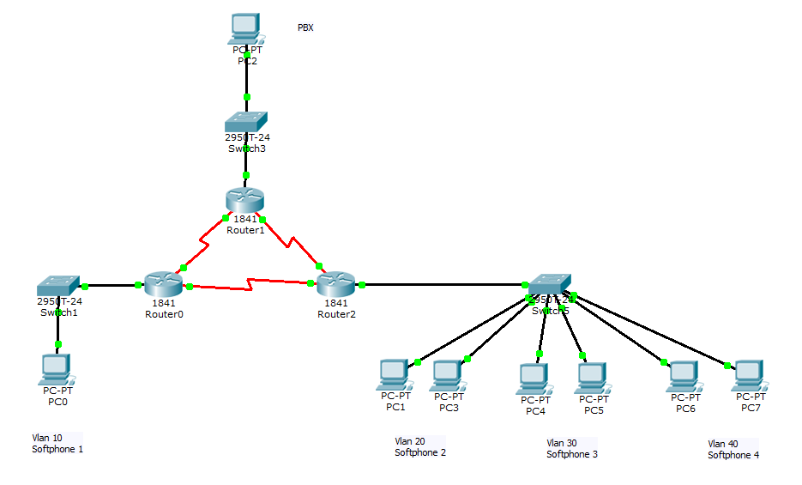
- Create the specified VLANs
- Configure LAN ip addresses
- Configure the routing protocols such as RIP, OSPF, EIGRP
- Make sure that devices can communicate with each other by using “ping” command

